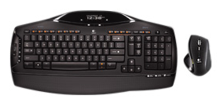
Some of you may have read my most recent keyboard review, Microsoft’s Natural Ergonomic Desktop 7000. I’m still using it, and the clacking space key is still driving my batty, and I was just telling someone that apparently I type “molters” a lot because my ERLMSTO letters have all worn off. Not long after that conversation, a keyboard gnome left a brand new Logitech MX5500 on my front step! Now I’m going to unplug this one and retire it to the stack of keyboards I have in my closet and plug in the new one. Here goes! Oh wait, let me read the instructions first…

The quick start guide states that the following should be included in the package.
1 Keyboard – check
2. Mouse – check
3. Charging base – check
4. USB-mini receiver – check
5. Software – check
6. 4 AA batteries – check

Instructions state
Step 1 – Turn on computer. Duh
Step 2 – Plug in USB device
Step 3 – Plug AC adapter into outlet – hmm this could be a problem. Is there anyone out there who actually has an unused outlet near their computer? I have a mess of squids and UPSs, but maybe I can find something unimportant to unplug….be right back.

Ok this is me on the new keyboard. Now I won’t take points off of this because it’s non-ergo, but I’ll stop typing when my hands cramp.
Step 5 – Turn on mouse. (apparently I didn’t read this one, since my mouse was not actual powered up and I was sitting here wondering why it’s not connecting…)
Step 6 – Put batteries in keyboard. (that took a while, I always feel like I’m going to snap the cover into pieces, particularly with this one where you have to slightly bend these two plastic rods to get the battery cover off. That’s a potential weak breaking point over time.)
Step 7 – Install software.
Step 8 – Profit! Oh wait, that’s the wrong gnomes.

Here goes!
First thing, wow this is QUIET. And I mean stealth quiet. The only noise is my thumb-ring hitting the space bar, and once I took that off, it was SO quiet, I’m blown away at how quiet this keyboard is. You could do some serious stealth typing with this. Did I mention it’s quiet?

The LCD display states NO TIME & DATE followed by
Please install my software!
Install il software.
Bonjour, installez mon logiciel.
!Hola! Instale mi software.
Installieren Sie die Software.

The instructions warn that if you already have SetPoint software installed to uninstall that. I did that ages ago, so we’re golden.

Now I’m typing this without a mouse present, as it is sitting in the charger, charging. According to the instructions, when all mouse LEDs are green, the mouse is fully charged, and when an LED turns red, to recharge it. Apparently a two hour charge provides up to 15 days of usage. Good to know. See you in two hours.

Software
Ok one restore point later (because I’m paranoid) it’s time to install the software.
Now I don’t usually start with the software, but this is the installation part. It’s pretty much what you’d expect from Logitech, quick, clear, and informative.
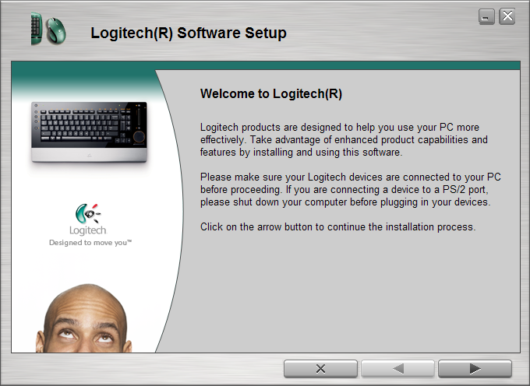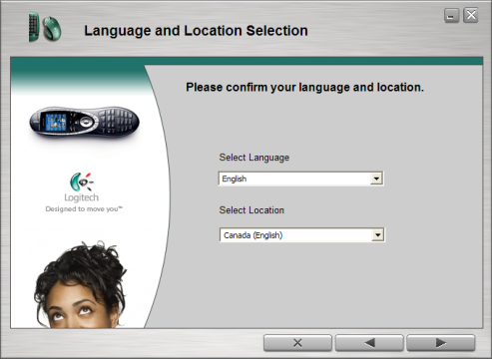
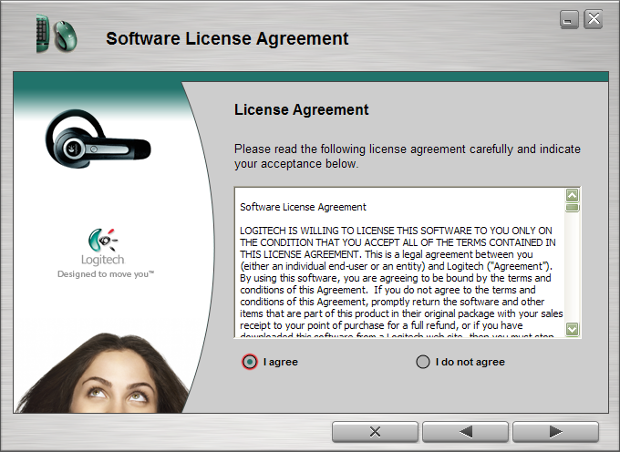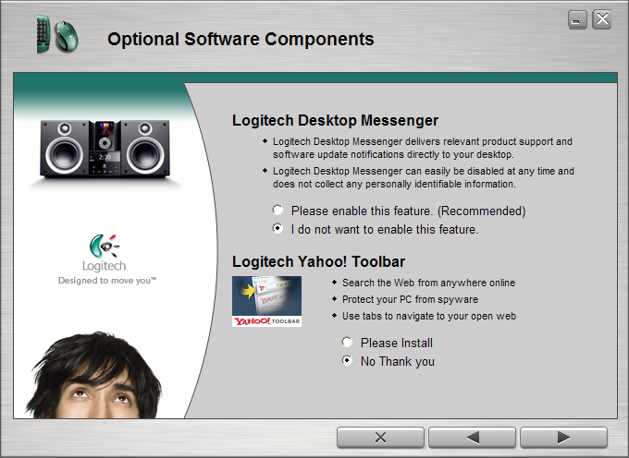
Pardon the interruption but just let me make a quick comment on that last one. Yahoo Toolbar? I think NOT. I really hope Logitech is getting paid well for that.
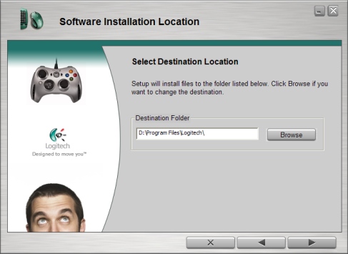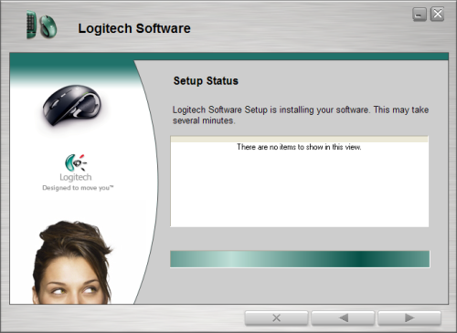
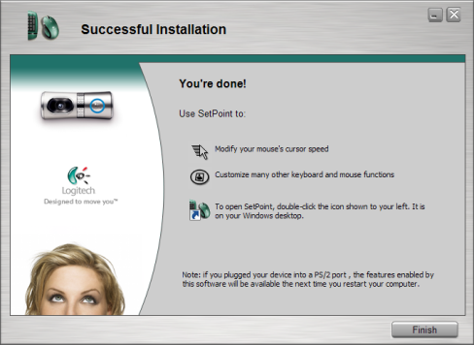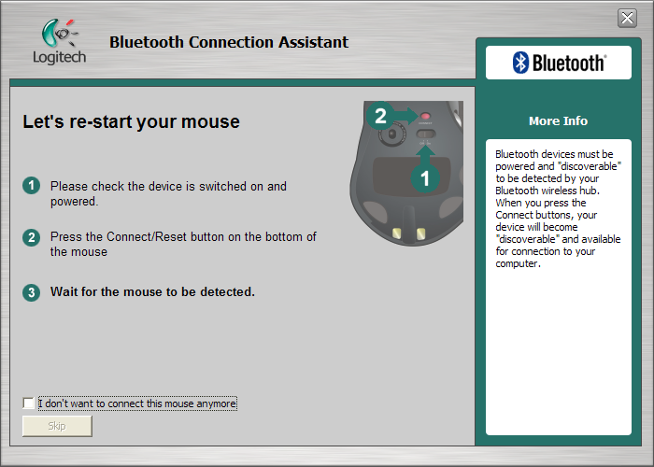
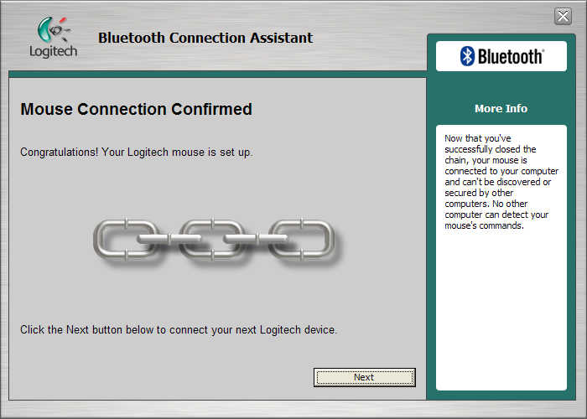
And we’re done. This whole process took under five minutes, was clear, concise and painless.
The mouse

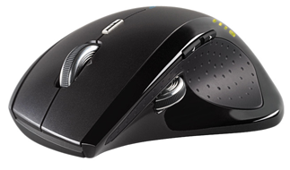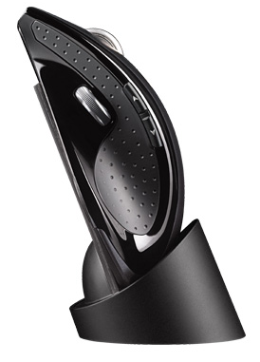
Well, I have to say, like any mouse, this mouse is going to take some getting used to. Right now I’m using a high profile rat that my hand cups around rather than rests on, it’s been rather comfortable and I’ve gotten quite used to it. This one is flat, almost too flat. There are two scroll wheels, however I have small hands, and can only reach the main one, not the secondary that is located in the thumb slot. If you have small hands, you’ll either have to grip this mouse quite differently than you’re used to or just not use the secondary wheel.

Immediately I have to say, I don’t like the ratcheting main mouse wheel, I prefer a much smoother scroll. The secondary mousewheel is unreachable unless I move my hand so far up the mouse that I’m practically falling off the front end. The mouse buttons themselves feel good, solid and not too loud, plus there is a mysterious button just below the mouse wheel. It does not appear to do anything, but I’m sure it is configurable in the setup interface. Oh wait, no there it opened my browser to Yahoo (ugh) it just took a very long time for it to register it was supposed to be doing something. You can configure what search page you want it to open to, just Yahoo, Google, Live and AOL. According to the window that pops up when you hold the mystery button down, you can “Highlight a word or phrase and press the button to instantly display results from your favorite search engine” I’m sure that’s useful in a browser but not terribly so in any other application.
The main mouse wheel itself is a little odd, it’s notched, so you really feel it turn, and it seems to be a little jerky because of the notching, however after you’ve given it a few spins it runs freely and very quickly (also see below on how to completely remove the ratcheting effect). The mouse wheel is not clickable, per se, but you can move it left and right. I have configured these movements to be back and forward, for web browsing.
The thumb area itself has not only the mouse wheel, but also two buttons of its own. Default for the wheel is document flip, the near button is page down (from what I can tell) and the far button is page up in Microsoft Word. In my browser these are back and forward a page. Now I did see something in the configuration that allows it to detect which application you are running, and set the buttons accordingly. Therefore, these attributes may change if I am in a game.

This is where Logitech does something that many other companies fail to do properly, their software is on par with the quality of their hardware. 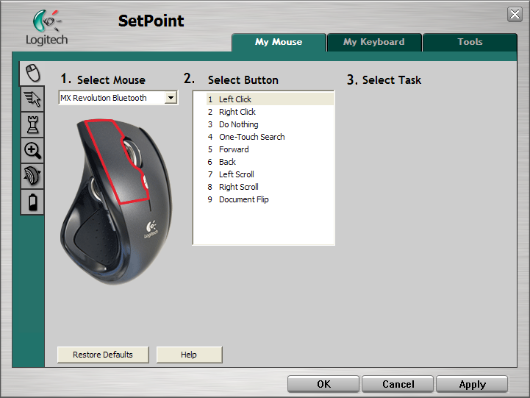
As you can see here, there are 9 different buttons on this mouse, from your usual right and left click, to one touch search, document flip, etc. Number three is labelled as ‘do nothing’ because this mouse wheel doesn’t actually click down, instead it rocks side to side, which is what numbers 5 and 6 control.
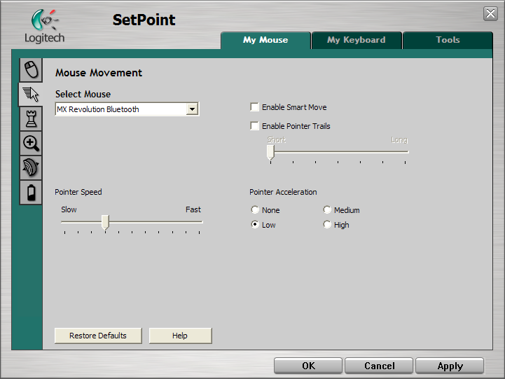
Here you can fine tune the performance of the mouse to your preferences.
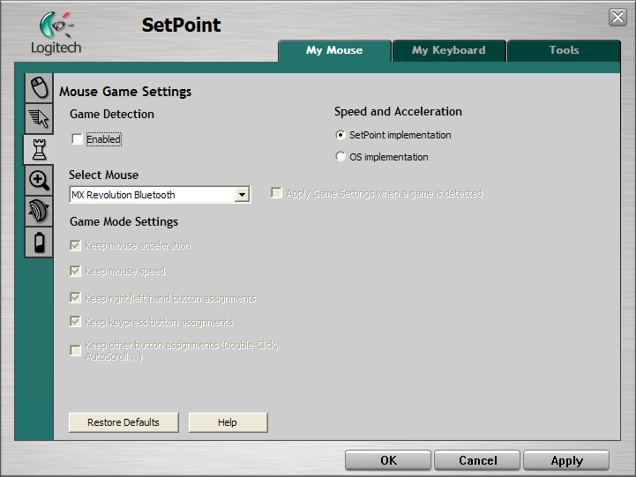
This is where you see the game detection enable option. This way you can set up your mouse different if you are playing a game. However, when I enabled this option, my only settings were the ones you see greyed out, I could not specify “This game – this layout” which is what I was expecting. Perhaps in 2.0.

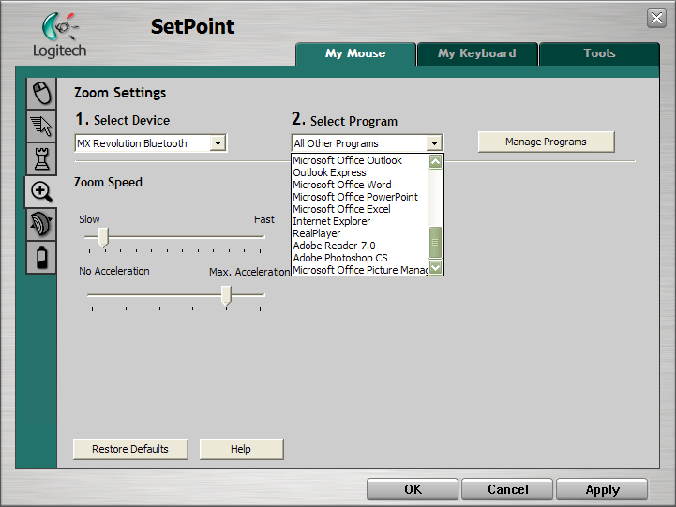
Here you see the ability to fine tune the speed and acceleration of your mouse, as well as define that behavior in many programs. Clicking on Manage Programs allows you to add programs to that list, however this appears to only apply to the zoom speed and not the above mentioned gaming mode.

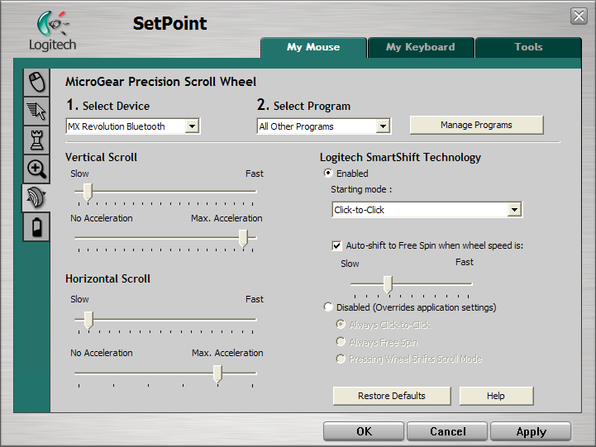
Here we see the mouse wheel configuration, and the aforementioned Free Spin options that are part of the SmartShift Technology. Thankfully, this is where I discovered you can disable SmartShift and select the “Always Free Spin” option for the mouse wheel! Yay! So for those of you who like a ratcheted mousewheel, and for those of us who like a smooth mousewheel, both are available with this mouse.

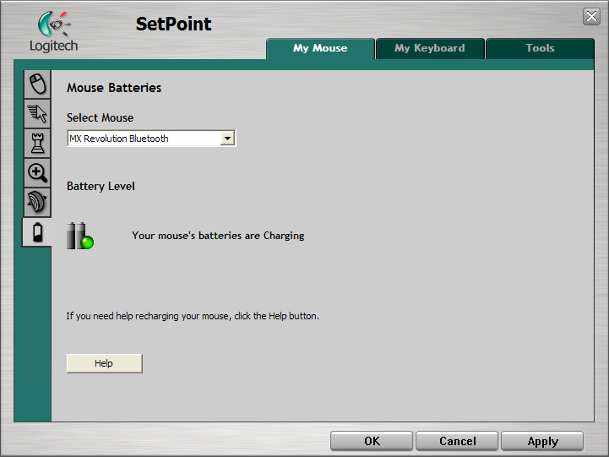
And finally for the mouse – battery level. This is indicated both here in the SetPoint software and physically on your mouse. A red LED on the mouse itself indicates you should probably charge it. Every time you move the mouse when it has been dormant for a short time, the battery indicator buttons appear to let you know the mouse has been activated as well as to let you know when you should charge it.
What I like about this mouse: Configurability, feels good in my hand. Low battery indicator.
What I don’t like about this mouse: Can’t reach all the buttons with a normal female sized hand, having to plug in a charger. Mouse wheel is a little too ‘free’ on free spin.

Keyboard
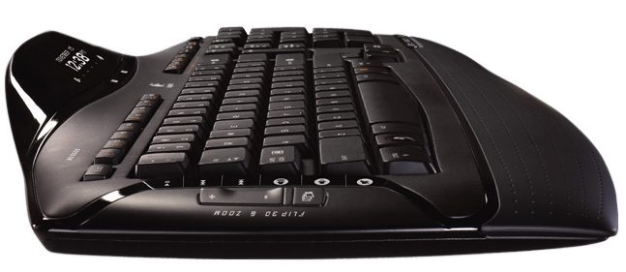
Physically this new keyboard is very low profile, and takes up considerable less desk space that its predecessor, the G15s and 20s, but only because it is lacking the three rows of shortcut keys on the left.

Speaking of keys, this thing is loaded with them. On the far left is Flip3D and Zoom buttons. Next in, are the music control buttons including the usual play/pause, restart, next, volume up, down and mute.
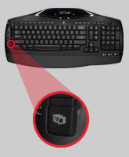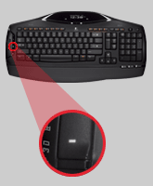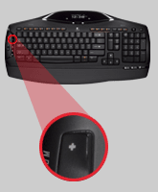
Across the top we have very low profile function keys, with a considerable split between F8 and F9. This may take some finger retraining particularly if you play games or use apps where you’ve already taught your fingers where these keys are usually located. And of course the function keys have alternate uses, here is the breakdown.
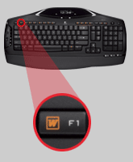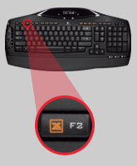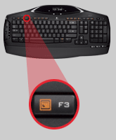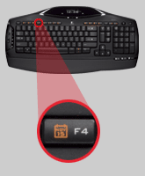
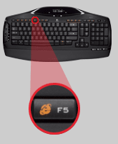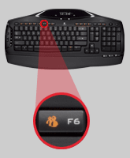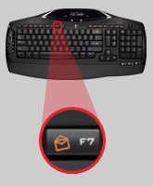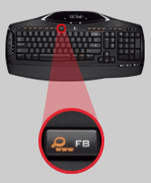
F1 – Opens Word Document
F2 – Opens Excel
F3 - Opens Powerpoint
F4 - Opens Calendar
F5 - Opens Explorer
F6 – Opens Messenger
F7 – Opens Outlook
F8 – Opens Browser to Search Engine

Now here is where it gets odd. F9 through to F12 are considered “Favorites” and are labelled A,B,C,D. These are also mirrored in the LCD display as Media Player, Search PC, Document and Control Panel respectively. However no where in the software could I find a way to reprogram these. The default options are not –my- favorites, I doubt they are yours, this would seem to be the one place to enable a large selection of customization. I put in a help ticket on their site and this is what I was told:
To program an F key on the MX-5500:
- Open an application (ie. Notepad) and make sure it is active.
- Press FN key and the F-key you want to program (ie. F9) at the same time and hold for 2 – 3 seconds.
- Verify that the LCD displays 'Please wait' briefly- it then returns to normal display.
- Close Notepad.
- Press FN + F9 and verify that Notepad launches.

Next to those, we have:
Insert; for which the secondary function is LCD control. This allows you to toggle between a white background with black text and a black background with white text.
Print Screen; for which the secondary function is to bring up a menu in the application you are currently working. As with the favorites, there is not indication of a way to reconfigure or even get a good explanation on this button.
Pause/Break; for which the secondary function is Scroll Lock.
Calculator: which is not what you think. This does not open your calculator; instead this is the Numlock toggle. Now why couldn’t they have just used the numlock icon? Or better yet, have this open your onscreen calculator, and add the Function on this key to toggle numlock?
Top upper right is a PC power button which I’m not going to touch mid-sentence. It enables a sleep function.
The Insert, Print Screen and Pause/Break keys are not programmable.

Blasted, they did it again. I have to say, I wish keyboard manufacturers would quit rearranging the home, insert, end, delete, pg up and pg dwn buttons. Pick a design and stick with it! They went from a two column three row config, to a three column two row config, and now back to a two column three row with the delete button being two rows high. Do we really delete that much?
Something new here is the array of Media Center, Photo Gallery and Gadgets buttons in the far bottom right of the keyboard.
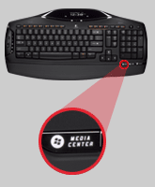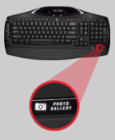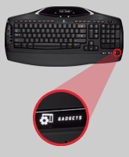

Media center does what you’d expect, if you have a Media Center enabled PC. For those of us who do not, well for me it opened iTunes for some strange reason. I didn’t even recall I had this installed.
Photo Gallery shortcut to the \My Documents\My Pictures folder which quite frankly I keep nothing in so that is of little use to me.
Gadgets loaded a Yahoo! Widgets page in my browser. What is Logitech’s obsession with Yahoo!?

Everything else is where you’d expect it, with the exception of Numlock Key, which appears to be hiding. Its normal position on the numpad is occupied by a Clear Calc button. I’m sure they didn’t miss it, it’s probably here somewhere, as a function of one of the other keys, we’ll see. I’ll let you know when I find it. According to their help desk:
As for the Num Lock function, you need to press the Calculator Mode key which is located between the Sleep Mode and the Pause/Break keys. It is directly above the number pad area.
Pressing the Calculator Mode key will allow you to toggle between normal number pad functions and the calculator mode which is displayed in the LCD on the keyboard.
Now lets talk about the LCD display.
After I installed its software as requested, I was able to get an accurate date and time which is good for reminding me just how late I’m staying up typing this review. There are two buttons below the display that cycle back and forth between all the display options that are default.
The first screen states No Media, so I fired up a media player to see if it actually noticed I was playing music – and it did! The artist, title and duration progress are all indicated. Next screen shows the temperature. It’s 81degrees Fahrenheit right now, I’m assuming that’s the room temp not my cpu temp.
The next screen displays my ABCD shortcuts mentioned above. Their destinations are shown, and the defaults are
A Media Player
B Search PC
C Document
D Control Panel

Next panel is a key counter. Jeez I’ve typed 20330 letters so far? Not terribly useful unless you’re getting paid by the letter, which I’m not.
Next panel is my inbox. Currently it states NO INBOX! When a new mail message arrives, a little tone comes out of my keyboard (and yes this can be disabled) to alert me to the mail, however the tone just made me think I’d had a keyboard error. Thankfully you can configure the sound it plays when actions occur such as receiving email, or hitting the capslock key.
And finally we’re back to the date and time and here’s something interesting to note.

THIS LCD IS NOT LIT
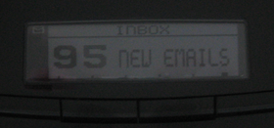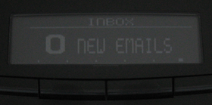
Because this is a battery operated cordless Bluetooth keyboard; powering a backlit LCD would drain the batteries rather quickly. Instead it is a black background with whitish lettering, or the alternative of a white background with black lettering which in a fully lit room, is still something I have to squint at. The above photos were taken midday in a lit room. Now I understand the reason for not having this backlit, but if that’s the price for having this keyboard cordless: it is too high. The only way this would be a useful feature is if you only used this keyboard in a daytime brightly lit space. Even then, it’s a little hard to read.

Overall, the MX5500 has its good points and its bad points.
The good comes from its absolute quietness, both the keyboard and mouse, battery level indicators, and programmability and size.
The bad comes from its hidden numlock, its home/end/del arrangement, the awkward to reach second mousewheel, and its price.
The really bad comes from its unlit LCD.

I always know I’m getting a quality product from Logitech, they haven’t failed me yet, but I feel this addition to their line of desksets falls short of expectations. I am not willing to trade Bluetooth for a visible LCD screen, eventhough the LCD screen has limited use. The fact there is an LCD screen certainly affects the price of this keyboard, coming in at approximately $170USD, and I do not feel that it is worth it. I’d much rather find myself a good G15 on sale. It may be corded, but I can actually see the LCD screen, and the keys themselves are backlit.

Overall rating 7/10

